- Introduction

- Over the course of the last twelve weeks, we’ve covered at lot about Heaven. We’ve looked at:

- Session 1: Introduction
- Session 2: The present/current heaven (in the sky)
- Session 3: The redemption of the earth (when the curse is fully lifted)
- Session 4: The resurrection of our bodies (and all creation)
- Session 5: The restored earth
- Session 6: The reality of living with God (in His direct presence)
- Session 7: Ruling with Christ (what it means)
- Session 8: Answering questions about life on the new earth
- Session 9: Answering questions about life in heaven
- Session 10: Answering questions about relationships in heaven
- Session 11: Answering questions about animals in heaven
- Session 12: Conclusion

- Reorienting Ourselves To Heaven As Our Home

Revelation 21:1,3-5 | …I saw a new heaven and a new earth… ³ And I heard a loud voice from heaven saying, “Behold, the tabernacle of God is with men, and He will dwell with them, and they shall be His people. God Himself will be with them and be their God. ⁴ And God will wipe away every tear from their eyes; there shall be no more death, nor sorrow, nor crying. There shall be no more pain, for the former things have passed away.” ⁵ Then He who sat on the throne said, “Behold, I make all things new.” And He said to me, “Write, for these words are true and faithful (trustworthy).”

- C.S. Lewis—“I must keep alive in myself the desire for my true country, which I shall not find till after death; I must never let it get snowed under or turned aside: I must make it the main object of life to press on to that other country and to help others to do the same.”

- Heaven is Home—Heaven on the new earth is our ultimate home. Home is what we long for when we’re on a long trip. Home is our center. It’s where we can relax, throw on sweatpants and just be. It’s the place, for most people, where things feel the most right. As good as our home is now, there’s a better home yet ahead. It’s our truest home. It’s when, after death, we rise again to live in a perfect world with a perfect God with fulfilling relationships and activities. “We were all made for a person and a place. Jesus is the person. Heaven is the place.” — Randy Alcorn

- Heaven Will Never Be Boring—At some point in your life, you’ve probably heard someone say something to the effect of, “I’d rather be having a good time in hell, than be bored in heaven.” This line of thinking is popular amongst unbelievers and even some embittered saints. But they have believed at least two great lies: 1) that God and righteousness is boring, and 2) that Satan and sin are fun. The fact is that hell is place of eternal torment and isolation, while heaven is a place of eternal friendship and laughter. Heaven will be the most exhilarating place we’ve ever been or fathomed could be. In heaven, says Pastor Mark Buchanan, “The ahh! of deep satisfaction and the aha! of delightful surprise meet, and they kiss.”

Psalm 16:11 | …In Your presence is fullness of joy; At Your right hand are pleasures forevermore.

- Heaven Is Meaningful—We can expect the following in heaven:

- Engaging, fulfilling work
- Cultural development and the endless use of creativity
- Singing, music, dance, storytelling, laughter and endless forms of godly, joyous art and entertainment
- Playing, sports, adventures, discoveries
- Fulfilling friendships and relationships with God and saints
- New opportunities that exceedingly outshine those lost in the old earth

Luke 6:21 | …Blessed are you who weep now, For you shall laugh.

- Good Heaven-Related Questions

- The following are some great questions from Randy’s book to consider:

- Do I daily reflect on my own mortality?
- Do I daily realize there are only two destinations—Heaven or Hell—and that I and every person I know will go to one or the other?
- Do I daily remind myself that this world is not my home and that everything in it will burn, leaving behind only what’s eternal?
- Do I daily recognize that my choices and actions have a direct influence on the world to come?
- Do I daily realize that my life is being examined by God, the Audience of One, and that the only appraisal of my life that will ultimately matter is his?
- Do I daily reflect on the fact that my ultimate home will be the New Earth, where I will see God and serve him as a resurrected being in a resurrected human society, where I will overflow with joy and delight in drawing nearer to God by studying him and his creation, and where I will exercise, to God’s glory, dominion over his creation?

- Perspective—We all live in this dot, which represents our entire life. But if we’re smart, we’ll be living for the line, which represents eternity.

- Quality Of Life “Peak” Diagram—Our life on this earth peaks and then regresses toward death. When we go to the current heaven, however, our life is profoundly enhanced. Yet, the current heaven doesn’t reach the glory of life on the new earth post-resurrection. There will be an ever-increasing satisfaction for eternity.

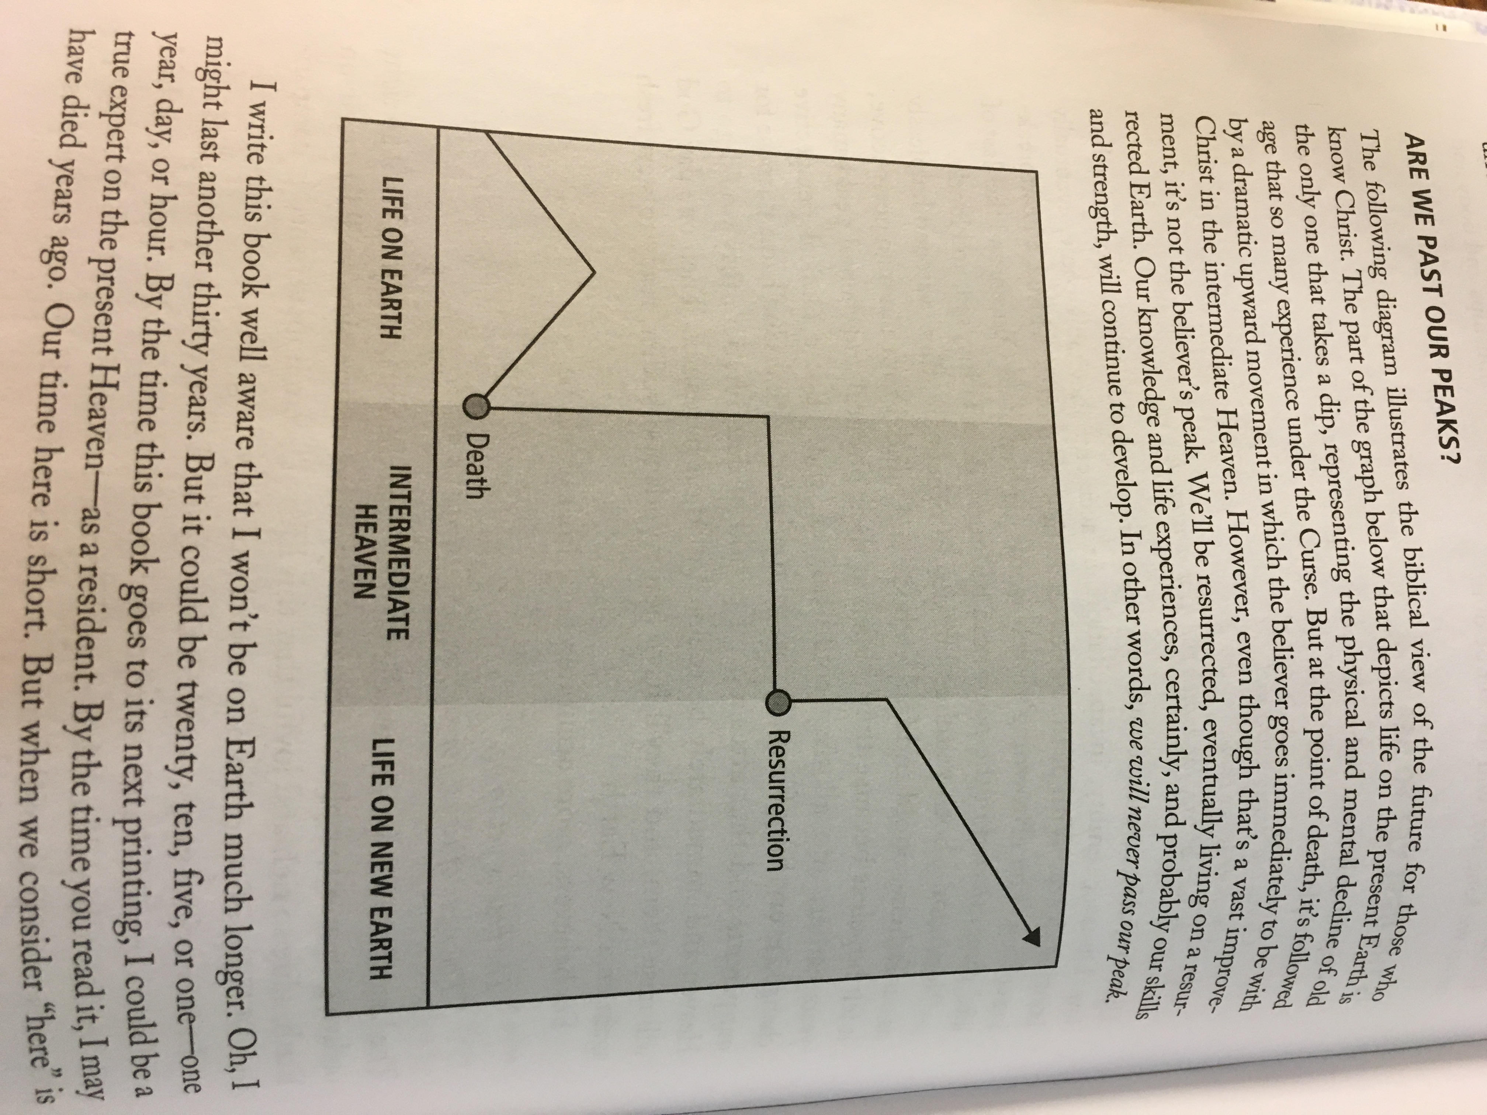

Help me improve my notes! The first person to find a legitimate mistake/typo on this document gets a real $1 bill.

Greater Peoria House of Prayer Announcements for February 13, 2016

- Welcome to the Greater Peoria House of Prayer… we’re glad you’re here and blessed to be worshipping God with you! Be sure to pick up the free materials at the back table in the prayer room or the desk near the front of the downstairs fellowship area, which includes teaching notes, stickers, pens, prayer cards and more. Daily schedule: We have morning prayer right here in this room seven days a week from 7 - 8 a.m. Monday - Friday and 8 - 9 a.m. Saturday and Sunday. We have afternoon prayer four days a week: Monday, Wednesday, Friday and Saturday from 11:30 a.m. - noon. We also have evening prayer with worship from 6 - 8 p.m. Monday - Friday. Our Friday Discipleship Night gathering is our weekly Friday evening prayer set that has a Scriptural discipleship focus to encourage those looking to grow in prayer and be more committed in their relationship with Jesus. Our Saturday Encounter Night is from 6 - 9 p.m. and is our main corporate gathering each Saturday evening featuring live worship and a teaching to inspire love for Jesus and prayer.

- Teaching series on Heaven: As of Saturday, November 14, we’ve begun a 12-week teaching series on Heaven as part of our regular Saturday Encounter Night. Derek is teaching on one chapter per week from Randy Alcorn’s book called Heaven. Consider purchasing Randy’s book on amazon.com or store.epm.org and read along week by week. Studying and understanding the biblical perspective on Heaven deeply fuels prayer and inspires us to keep our focus on things above.

- Use your leadership and musical talents for God’s glory: If you are interested in leading or ministering during a live worship set by singing, playing an instrument, prayer leading or behind the sound board, please contact us at gphoprayer@gmail.com. We’d love to have you serve on one of our teams!

- Prophetic and healing ministry: If you feel the Lord has gifted you in the prophetic (or would like to grow in this gifting) and would consider leading/helping on a team, contact Kaity Vance at ktlyn777@yahoo.com. Contact Mandy Kistner at mandykistner@yahoo.com if you would like to schedule a future healing ministry appointment or help out on the healing team.

- Missions: Please keep the following missionaries we support in prayer as well as be sensitive to their financial needs: Ashley Bucknam (ACTS School, Colorado Springs, CO); Tim and Blair Fraim (Florianopolis House of Prayer; Florianopolis, Brazil); Eric and Erin Simmons (Minnesota House of Prayer Network; Twin Cities, Minnesota).

- Social media: Follow us on Facebook (Greater Peoria House of Prayer - GPHOP), Twitter (@GPHOPrayer) and Instagram (@GPHOPrayer) for regular updates and inspiration. Use these social media sites to get the word out, share pictures, quotes you heard, etc. Contact Derek at derekkistner@yahoo.com if you’re interested in helping with GPHOP’s social media.

- Refuge ministry: There are several groups who use our facility for their ministry purposes. Please keep the following in prayer: Christian Business Men’s Connection Bible studies (Thursday mornings), Kinisi 424 senior worship leader meetings (monthly/as needed), Garage Thinkers kingdom entrepreneurialism class (2nd/4th Tuesday nights) and Sunday church gatherings (as needed).

- We provide free wifi to everyone here! The password for the NETGEAR33 router is dynamicflower809 (all lower case, no spaces). You can also connect to either the CableWiFi or xfinitywifi routers if you have a personal Comcast account.

- Prayer requests: If you have a prayer request that you would like our prayer teams to pray for regularly, please submit it to gphoprayer@gmail.com.

- Giving: The minimum prayer room budget is about $3,000 per month. If you have been blessed by the GPHOP and would like sow financially into the ministry, we would be more than blessed. You can give in cash, but if you would like to give to GPHOP with a check, please make it out to “Greater Peoria House of Prayer” or “GPHOP”—your gift is tax deductible. Thank you for your generosity! It’s helping make day and night prayer with worship possible in central Illinois. You can place your gift in the Saturday night offering during the 7 p.m. teaching or drop it in the black donation box on the wall near the front of the prayer room. Donations can also be mailed to our address at 117 East Washington Street, East Peoria, IL 61611.

Thank you for helping to keep this prayer room sacred by ensuring conversations with others are brief and kindly reminding others to do the same. There is a large fellowship area downstairs if you would like to talk at length.

